Data Base and PDO

Exercise

Submitted by: Bruno Angelo Medeiros

Member country/region: BRAZIL

## PROJECT DESCRIPTION

You were hired to develop the database with a CRUD. Your job is to develop all systems with PDO.

## INstruction to competitor

To finish this task, the database model is given to you to base on it.

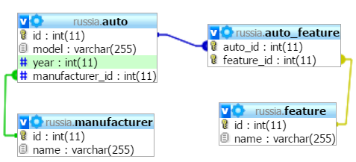

The CRUD contains 4 main sections

* Create
* Read (List)
* Update
* Delete